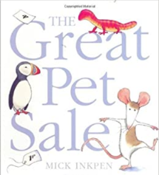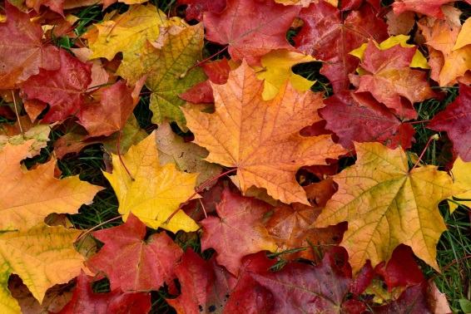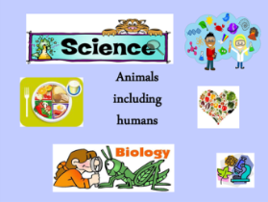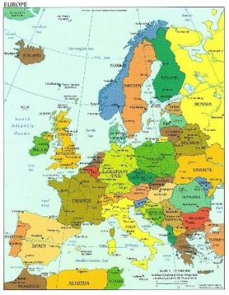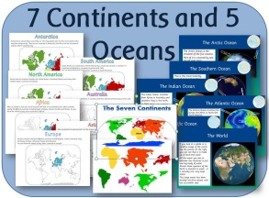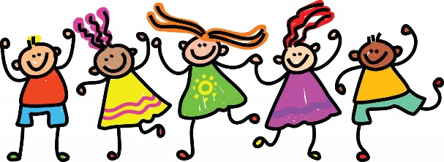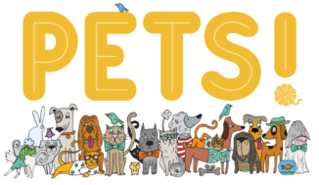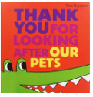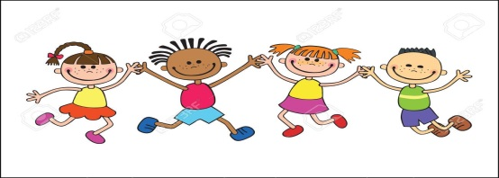

**Art, DT & Music**

**ART**

* We will explore drawing to develop and share our ideas, experiences and imagination. We will be using a range of materials creatively to design and make a collage.

**Music -** Following the West Sussex Music Programme: Pulse and Rhythm + notation

* Steady pulse
* Moving to music
* Copy back more complex rhythms, read rhythms, create using symbols
* Standard names of notes

**Foundation Subjects**

**RE**

* This half term our focus is on Christianity and its Saints. We will explore a range of Christian beliefs, values and celebrations, whilst exploring important stories to learn about the main beliefs and concepts of Christianity.

**Geography**

* We will be asking and answering geographical questions, as well as using world maps, atlases and globes to identify the United Kingdom and its four countries. We will also look at countries around the world, the seven continents and five oceans.

**Science**

**Science – Animals, including humans**

* We will be finding out about and describing the basic needs of animals, including humans; whilst recognising the importance for humans to exercise, eat the right amounts of different types of food and personal hygiene.

**MINI LEARNING JOURNEY – ‘What a Wonderful World!’**

Over the first 2 weeks of the new school year, we will be working together to learn about ourselves and others. We will be making the most of opportunitites to talk to each other so we can get to know each other better. The learning will provide the children with opportuities to reflect as well as look forward; think about what makes them who they are and where they see their place in the world. This will consider their immediate world such as friends and family but we will also explore, enjoy and learn from stories and lives of people living in the continent of Europe.

**Mathematics**

**Number - Place Value**

* Count in steps of 2, 3, 5 from 0, and in tens from any number, forward and backward.
* Read and write numbers to at least 100 in numerals and in words.
* Begin to recognise tens and ones
* Represent numbers using objects and pictures
* Use and understand place value charts
* Compare objects, order objects and numbers

**Number – Addition & Subtraction**

* Fact families
* Check calculations
* Compare number sentences
* Related facts Bonds to 10
* Add and subtract 1s; Ten more and ten less; Add and subtract 10s

**Money**

* Count money in pence, pounds, notes and coins
* Select money
* Make the same amount
* Compare money
* Find the total, difference and change
* Solve two-step problems

**French**

For the Autumn Term, we will be focussing on

- greetings

- please & thank you

- colours

- counting 1,2,3,4,5

**KEY TEXTS**

* **The Great Pet Sale by Mick Inkpen**
* **Thank you for looking after our pets by Tim Hopgood**
* **Non-fiction texts and information about pets and how to care for them**

**English**

**Speaking and Listening**

This half term we will be learning to give an opinion with a reason, listen to others’ opinion and appreciate that they could be different to our own. When exploring poetry, we will recite and perform simple poems and use this experience to write our own.

**Reading**

This half term we will be getting to know our key text really well so we can retell stories by sequencing key events. We will make predictions about possible events and why characters are behaving in certain ways. We will begin to explore inference and reading between the lines to gauge what the writer is trying to tell the reader.

**Writing (half term focus; story writing, poetry and non-fiction writing)**

This half term we will be learning to understand that there are different purposes for writing and how we decide upon the best one for what we want to write about. We will be talking about ideas for writing and sharing these with others, whilst using suggested models to map these ideas out (e.g. Story Mountains)

‘EVERYTHING MUST GO!’ said the sign on the pet shop window…

**Europe Class - Autumn 1**

**RSHE**

**Core School Value: INSPIRE – Wider Values: Curiosity & Motivation**

* We will explore what it means to be inspired and how we can be an inspiration to others. We will recognise that we all have similarities and differences but will respect these and show support and motivation to our peers. We will learn how to be curious and how we can use our curiosity to help us learn.

**Growth Mindset**

* We will continue to develop our growth mindset by thinking about ourselves and learning from experience. We will use the skills of perseverance, motivation and success to help us achieve.

**PE**

**Invasion Games**

We will be developing our basic movements including throwing, catching, dribbling, hitting and kicking through a range of invasion games.

**The Secret Life**

**of Pets!**

**EUROPE**