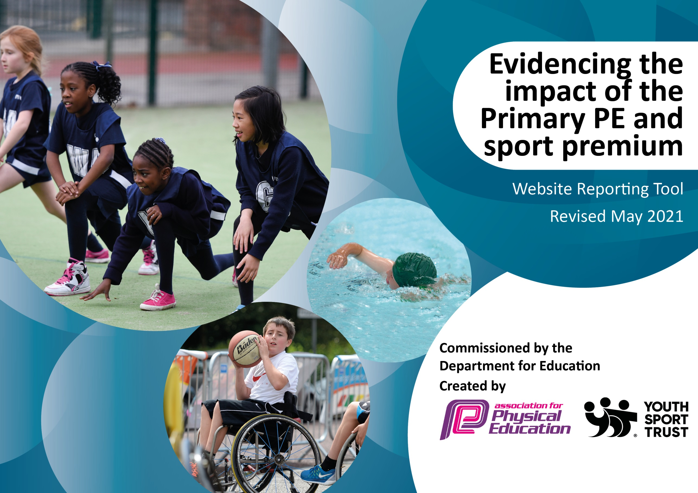

It is important that your grant is used effectively and based on school need. The Education Inspection Framework (Ofsted 2019 p64) makes clear there will be a focus on ‘whether leaders and those responsible for governors all understand their respective roles and perform these in a way that enhances the effectiveness of the school’.

Under the Quality of Education criteria (p41) inspectors consider the extent to which schools can articulate their curriculum (INTENT), construct their curriculum (IMPLEMENTATION) and demonstrate the outcomes which result (IMPACT).

To assist schools with common transferable language this template has been developed to utilise the same three headings which should make your plans easily transferable between working documents.

Schools must use the funding to make additional and sustainable improvements to the quality of Physical Education, School Sport and Physical Activity (PESSPA) they offer. This means that you should use the Primary PE and sport premium to:

- Develop or add to the PESSPA activities that your school already offer
- Build capacity and capability within the school to ensure that improvements made now will benefit pupils joining the school in future years
- The Primary PE and sport premium should not be used to fund capital spend projects; the school’s budget should fund these.
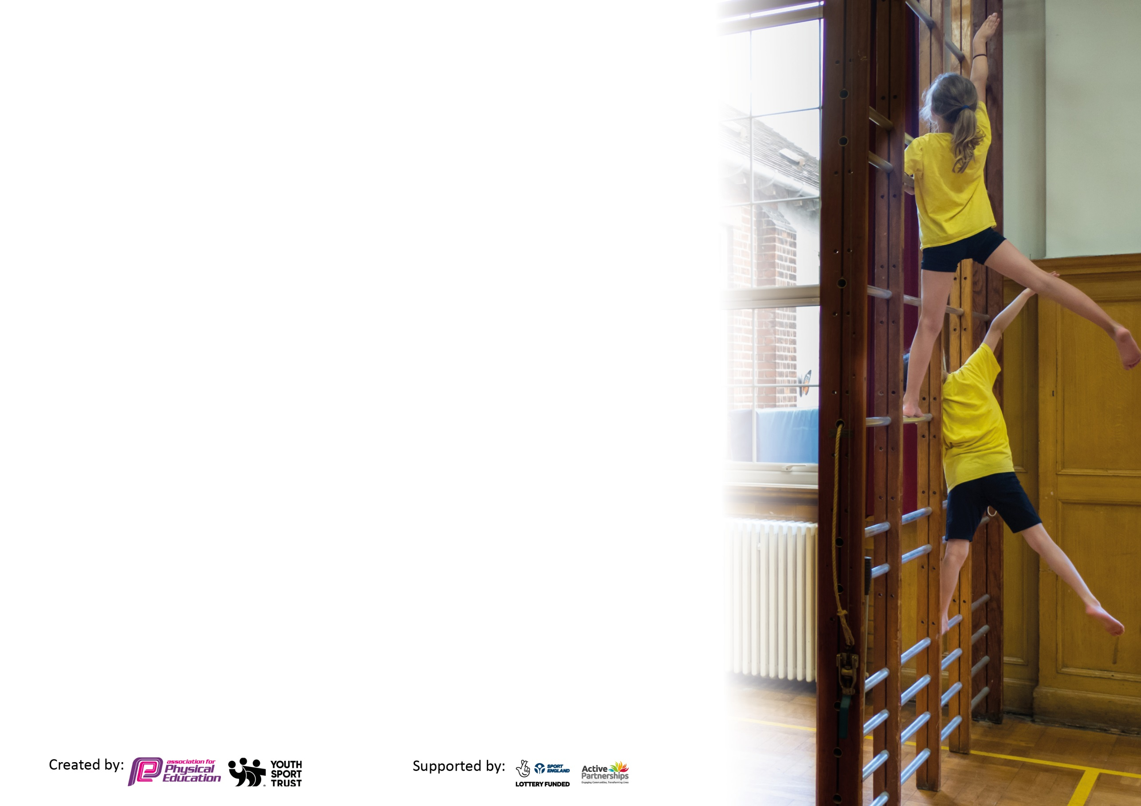
Please visit gov.uk for the revised DfE guidance including the 5 key indicators across which schools should demonstrate an improvement. This document will help you to review your provision and to report your spend. DfE encourages schools to use this template as an effective way of meeting the reporting requirements of the Primary PE and sport premium.

We recommend you start by reflecting on the impact of current provision and reviewing the previous spend.

Schools are required to publish details of how they spend this funding, including any under-spend from 2019/2020, as well as on the impact it has on pupils’ PE and sport participation and attainment by the end of the summer term or by 31st July 2021 at the latest.

We recommend regularly updating the table and publishing it on your website throughout the year. This evidences your ongoing self-evaluation of how you are using the funding to secure maximum, sustainable impact. Final copy must be posted on your website by the end of the academic year and no later than the 31st July 2021. To see an example of how to complete the table please click HERE.

Please note: Although there has been considerable disruption in 2020 it is important that you publish details on your website of how you spend the funding - this is a legal requirement.
Support for review and reflection - considering the 5 key indicators from DfE, what development needs are a priority for your setting and your pupils now and why? Use the space below to reflect on previous spend and key achievements and areas for development.

N.B. In this section you should refer to any adjustments you might have made due to Covid-19 and how these will influence further improvement.
Key achievements to date until July 2021: | Areas for further improvement and baseline evidence of need:
Due to Covid-19 restrictions this year, there have been no medals awarded for the Primary School Games; however due to our ongoing commitment, we have continued to promote and maintain the PE curriculum.  - Participation in tri-golf tournament organised by the School Games Programme during the summer term. The children who took part came 1st in the heats and played a final run by Barry Meaney. These intra school competitions continue to support our school ethos and values.  - Qualified PE teacher employed to raise standards in PE continues to promote and develop the PE curriculum across the whole school. Teaching well-planned and progressive lessons that teach and develop a range of skills. They also provide continuous CPD for the staff.  - As Covid-19 restrictions lifted a little, the commencement of after-school clubs occurred. These included multi-sports rugby, gymnastics and dance. The school have covered the cost for every disadvantaged child to take part in these to ensure their physical well-being is promoted.  - The children have at least 45 minutes of free play and break and lunch times. Each class has equipment assigned for them to use to remain Covid compliant.  - During lockdowns we continued to give PE a high focus. We supported and encouraged parents to do some physical activity every day, as well as using the School Games Programme ideas as part of the remote learning planning.  - The school has provided a dance workshops (Kicks Dance) for 5 weeks during the Summer term.  - The all-weather track is in use every day by all classes.  - We carry out mindfulness sessions daily to promote a physical rest and reboot the mind, body and soul.  - Woodland learning taster sessions have been carried out across the school during the Summer term. This has provided CPD for all staff.  - We have ordered more sports equipment to ensure all children have the opportunity to use and explore with it during the taught sessions and at playtimes.  - Despite Covid-19 restrictions being extended, we went ahead with the whole school sports day with the children. Empowering all children to be involved in physical activity and intra house competitive activities. | -For Inter school competitions to recommence, once we can ensure they can be Covid- 19 safe.  - For swimming to start up again in Year 3, once Covid-19 restrictions allow.  - For the implementation of Woodland learning to occur across the whole school following the taster sessions in Summer term 2021  - For dance and gymnastics to be a focus going forward in terms of teaching. Staff survey to be carried out to acquire an understanding of CDP and confidence.

Did you carry forward an underspend from 2019-20 academic year into the current academic year? YES/NO * Delete as applicable
Total amount carried forward from 2019/2020 £11463.76
+ Total amount for this academic year 2020/2021 £17770
= Total available to spend by 31st July 2021 £29233.76
Planned spend by 31st July 2021 £24822.87
Carry forward to 2021/2022 £4410.89
Meeting national curriculum requirements for swimming and water safety.

N.B Complete this section to your best ability. For example you might have practised safe self-rescue techniques on dry land which you can transfer to the pool when school swimming restarts.
Due to exceptional circumstances priority should be given to ensuring that pupils can perform safe self rescue even
if they do not fully meet the first two requirements of the NC programme of study.
What percentage of your current Year 6 cohort swim competently, confidently and proficiently over a distance of at least 25 metres?  N.B. Even though your pupils may swim in another year please report on their attainment on leaving primary school at the end of the summer term 2021.  Please see note above. | 90% - based on parental surveys returned  66.6% of whole cohort
What percentage of your current Year 6 cohort use a range of strokes effectively [for example, front crawl, backstroke and breaststroke]?  Please see note above. | 90% - based on parental surveys returned  66.6% of whole cohort
What percentage of your current Year 6 cohort perform safe self-rescue in different water-based situations? | 70% - based on parental surveys returned  51.8 % of whole cohort
Schools can choose to use the Primary PE and sport premium to provide additional provision for swimming but this must be for activity over and above the national curriculum requirements. Have you used it in this way? | Yes/No

Action Plan and Budget Tracking
Capture your intended annual spend against the 5 key indicators. Clarify the success criteria and evidence of impact that you intend to measure to evaluate for pupils today and for the future.

Academic Year: 2020/21 | Total fund allocated: £21642.27 | Date Updated: July 2021
Key indicator 1: The engagement of all pupils in regular physical activity – Chief Medical Officers guidelines recommend that primary school pupils undertake at least 30 minutes of physical activity a day in school |  |  |  | Percentage of total allocation:
 |  |  |  | %
Intent | Implementation |  | Impact | 35.25%
Your school focus should be clear what you want the pupils to know and be able to do and about  what they need to learn and to  consolidate through practice: | Make sure your actions to achieve are linked to your intentions: | Funding allocated: | Evidence of impact: what do pupils now know and what can they now do? What has changed?: | Sustainability and suggested next steps:
Ensure the standard of play and engagement of all pupils during break and lunch times remains high by - maintaining the use of a lunch/play coordinator.  All children to take part in at least 30 minutes of daily physical activity by providing a way for children to access a sports clubs and complete the daily mile.  Maintenance of equipment to ensure health and safety and constant access; whilst sufficient high quality equipment is available to all pupils. Implement a cycle rack and area to leave bicycles/scooters during the school day to promote ‘walking to school’.  Provide support for teachers to deliver some means of physical exercise in class when hall is out of use and at times of inclement weather (Jump Start Jonny)  After school clubs to be offered and for the school to cover the cost of all disadvantaged pupils so they may attend.  Woodland learning to be offered to all children to alleviate the effect of Covid-19 | Order new equipment for children to use during their play-times so their play can be focused and purposeful.  All-weather track to continue to be maintained, as well as the school field and outside areas for playtimes.  Make use of the track by setting the expectation for all children to complete a daily mile, promoting team spirit and physical wellbeing.  Servicing of hall apparatus  Audit by PE leader & specialist teacher and subsequent purchase of equipment  Purchase and fit cycle rack and shingle area.  Purchase balance equipment for the engagement of children with specific physical needs.  Continued subscription to the programme for all staff to use.  Emails to parents to offer after school clubs once Covid-19 restrictions are lifted. Ensure parents of disadvantaged children are aware that the school will cover the cost.  Specialist teacher to undergo woodland learning training and qualify at a level 3 ready to teach all pupils.  Trees to be maintained to ensure woods are safe to use. | £129.98 – see costs for equipment  £1680 – see costs for grass cutting  £48  £285  £39.95  £224.92– see costs for, universal services, cycle rack and shingle and balance equipment  £219 – see costs for Jump Start Jonny  £263.50  £54  £75  £1650 – see costs for p/prem club places and kicks dance  £2100  £3536 – See costs for salaries and tree maintenance | Playtime and lunchtime observations of children continue to show more children actively involved in games. The quality of play is raised as the children are using the quality equipment such as balls, cones to support their play.  All children are very keen to get their time on the track each day. The competitive spirit that comes with it is healthy and the improvement of the children’s stamina throughout the year has been impressive! Children in Year 5 are now easily completing 10 laps in around 15 minutes.  Equipment still serviced and maintained despite not being in use during to Covid-19 regulation. It is safe and ready to use next year, once Covid regulations allow.  Cycle rack is in constant use and children are able to access their bikes safely at the end of each day. Children talking more about cycling to school, which is positive. Easy access to sufficient equipment means that children enjoy a wide range of opportunities to experience a range of sports and develop key skills.  Jump start Jonny has been used more intermittently this year as we have tried to be outside as much as possible. The programme was used and promoted to parents for physical activity during remote learning. It is a way to stay fit and healthy whilst removing the need for equipment during the Covid-19 pandemic.  The after school clubs that have been run over the summer term, once Covid-19 restrictions lifted, have been immensely popular. By covering the cost for the disadvantaged children they have been able to access a range of opportunities and develop lots of physical skills. The clubs have also promoted positive mental health through teamwork and collaboration. A total of 15 disadvantaged children were financially supported to attend these clubs.  The woodland learning taster sessions have provided positive learning opportunities, which are Covid-19 safe, whilst developing physical skills. All children have had several sessions and have learnt things from whittling woods to using a range of tools and techniques. | Monitor continued use of equipment at playtimes and what is being accessed. Ensure equipment remains useable and reorder and update as necessary. Continued monitoring by staff to promote positive and purposeful play.  All classes to continue to make use of the all-weather track during the day for spontaneous activity breaks.  Reintroduce a morning running club.  Sustainable whilst PESPA funding is available  Ensure that new staff are familiar with the programme and are able to use it when the hall is out of use and weather is inclement. This will be very useful if social distancing tightens once more, as a way for pupils to be physically active inside their group.  Continue to implement a range of after school clubs and if costing is sustainable, provide this service for all disadvantaged children.  Use the skills the children learnt this year and implement them into a dance element for the Christmas and Summer performances.  Rebook the dance workshop for next year.  Timetable to be drawn up to ensure all children will be taught woodland learning at some point during the year. The children who experienced the taster sessions will put their previous knowledge into action as well as learning new skills.
Key indicator 2: The profile of PESSPA being raised across the school as a tool for whole school improvement |  |  |  | Percentage of total allocation:
 |  |  |  | %
Intent | Implementation |  | Impact | 4.5%
Your school focus should be clear what you want the pupils to know and be able to do and about  what they need to learn and to  consolidate through practice: | Make sure your actions to achieve are linked to your intentions: | Funding allocated: | Evidence of impact: what do pupils now know and what can they now do? What has changed?: | Sustainability and suggested next steps:
Maintain the engagement of all children in physical activity by identifying those less active and implementing a range of activities including daily use of the running track, daily mindfulness, whole school physical fundraising events and free play times.  Equipment to be purchased to update the existing resources and ensure that there are enough pieces of equipment for all. | Children will continue to use the all-weather track every day to aid their physical and emotional well-being.  Children will take part in daily mindfulness sessions to support them mentally and offering time for reflection and calm.  Children will be encouraged to participate in whole school events with a physical and sporting focus.  PE sports leader & specialist to find gaps in equipment and purchase as necessary. | £631.50  £62.45  £12.94  £185.13  £401.39  £20.81 – see costs for sports equipment order Nov 20, table tennis bats and balls, flexi bar lath, sleepers for the butterfly garden, fence for the vegetable garden and tennis racquet grips. | Upon using the all-weather track every day, it has been noticed that the mental capacity of the children has increased and they are all keen and eager to get their time on the track each day.  The regular mindfulness sessions have been vitally important to promote a need to rest our minds, reflect on our capabilities and our breath and refocus ourselves ready for the rest of the day. The implementation of the butterfly garden in the summer term has provided a beautifully, peaceful place that children an access freely or within a planned mindfulness session. The school vegetable garden has also provided much needed mindfulness time. The investment of a fence has allowed this area to be clearly section, making it a secluded and ideal retreat for children to partake in the physical act of gardening.  The school took part in a sponsored spring time scramble in the spring term. This was a Covid-19 safe activity carried out at school on the field and all-weather track. The camaraderie and team spirit it brought to the children’s day was wonderful to see and it gave them a sense of belonging and how we can work successfully together. | Continued use of the all-weather track.  Implement some sort of record so children can assess and observe their own personal progress over a term, the school year etc.  Continue with the daily mindfulness sessions so children can have the opportunity to reflect and refocus their minds.  Utilise the butterfly garden and vegetable patch across the school.  Carry out another spring time scramble or similar event to raise team spirit and working together.

Key indicator 3: Increased confidence, knowledge and skills of all staff in teaching PE and sport |  |  |  | Percentage of total allocation:
 |  |  |  | %
Intent | Implementation |  | Impact | 31.32%
Your school focus should be clear | Make sure your actions to | Funding | Evidence of impact: what do | Sustainability and suggested
what you want the pupils to know | achieve are linked to your | allocated: | pupils now know and what | next steps:
and be able to do and about | intentions: |  | can they now do? What has
what they need to learn and to |  |  | changed?:
consolidate through practice:
Use a PE specialist teacher to teach alongside class teachers to deliver areas of the PE curriculum where teachers feel less confident and secure in their own understanding.  Dance workshop to provide CPD for staff and develop their confidence to teach sessions following this. | PE specialist teacher to timetable time with each class for delivery of PE.  Class teachers to identify areas where they are less secure in their knowledge/confidence.  PE specialist to teach a model lesson for the class teachers to actively participate in.  Class teachers to teach follow up lessons engaging strategies and knowledge delivered by PE specialist with support.  Specialist dance teachers to plan and teach a succession of progressive lessons that will promote physical activity, as well as emotional well-being. These sessions will also aim to improve the teacher’s CPD so that they can take it on to teach it themselves. | £7505.30 – see costs for salaries  £1650 – see costs for Kicks dance | Due to the pandemic, restrictions and lockdowns, the staff have had limited time to implement knowledge gained from the previous year’s CPD. However, extra emphasis has been put on observing and taking part in the sessions taught by the specialist teacher. All staff join in with the sessions to gain an understanding of what a succession of lesson looks like and these encompass a range of sports – tennis, cricket, athletics etc. Class teachers reported that they felt more confident in delivering lessons after observing the skills and techniques used by the PE specialist.  Class teachers reported a better understanding on how to deliver and build upon lessons during a unit of teaching.  The Children have loved all the opportunities to develop their physical skills. They are always actively engaged in lessons, and the pace of lessons is purposeful. | Continue to implement these sessions taught by the PE specialist so that all staff may develop their CPD by attending these.  Use the skills the children learnt this year and implement them into a dance element for the Christmas and Summer performances.  Rebook the dance workshop for next year.
Key indicator 4: Broader experience of a range of sports and activities offered to all pupils |  |  |  | Percentage of total allocation:
 |  |  |  | %
Intent | Implementation |  | Impact | 1.54%
Your school focus should be clear | Make sure your actions to | Funding | Evidence of impact: what do | Sustainability and suggested
what you want the pupils to know | achieve are linked to your | allocated: | pupils now know and what | next steps:
and be able to do and about | intentions: |  | can they now do? What has
what they need to learn and to |  |  | changed?:
consolidate through practice:
Additional achievements:  Ensuring that all children have access to a physical curriculum (even through remote learning if schools are in lockdown)  Keep up the links with the school locality scheme and use these to make sure the children take time to go out every day, as well as having opportunities to take part in inter or intra sports competitions.  Year 6 will attend a planned residential trip – covid-19 dependent.  School clubs to take place – Covid-19 dependent. | Children will continue to be provided with a balanced curriculum, one where physical activity is promoted and celebrated.  Barry Meaney will continue to be in touch with the school offering specific coaching, remote learning ideas and competitions.  Year 6 will attend a residential that will help them to develop new skills, focusing no team-work, challenge and new activities that they have yet to experience within in a school setting.  Try to implement school clubs such as rugby, multi-sports, dance, gymnastics etc. | £450 – costs for Go Ape | By providing these additional learning opportunities we have continued to offer a wide range of physical activities and sports to all pupils.  During this challenging and difficult year, we have worked hard to maintain the links with our locality sports networks so that we can continue to promote and develop the importance of physical activity, well-being and mindfulness.  The children in Year 6 were able to attend an on-site residential and participated in a wide range of physical sports. They went to the Adur Centre in Shoreham where they had a go at shooting, kayaking and rock-climbing – new activities for lots of the children. They visited Go Ape in Crawly where the aim is to navigate their way around a set of high-ropes; a new physical learning opportunity for them this year. Finally Barry Meaney provided a collaborative team building day where they worked together to complete orienteering activities and developing their skills to work outside.  The after school clubs were run over the summer term, once Covid-19 restrictions lifted, have been immensely popular. By covering the cost for the disadvantaged children they have been able to access a range of opportunities and develop lots of physical skills. The clubs have also promoted positive mental health through teamwork and collaboration. A total of 15 disadvantaged children were financially supported to attend these clubs. | Ensure the links remain between us and the locality schools network and look forward to participating in many more competitions as the Covid-19 restrictions and guidelines continue to ease.  For Year 6 teaching staff to plan and organise a residential trip for 2022 that will offer a broader experience of a range of sports.  Continue to implement a range of after school clubs and if costing is sustainable, provide this service for all disadvantaged children.

Key indicator 5: Increased participation in competitive sport |  |  |  | Percentage of total allocation:
 |  |  |  | %
Intent | Implementation |  | Impact | 12.31%
Your school focus should be clear | Make sure your actions to | Funding | Evidence of impact: what do | Sustainability and suggested
what you want the pupils to know | achieve are linked to your | allocated: | pupils now know and what | next steps:
and be able to do and about | intentions: |  | can they now do? What has
what they need to learn and to |  |  | changed?:
consolidate through practice:
Use the school games activities and local sports academy membership to provide children with access to a range of competitive sporting events across several different sporting areas.  Plan and carry out competitive sports days for KS1 (inc. Rec) & KS2 | Engage in the local sports academy partnership.  Prepare and present teams to locality sports events, where children compete against up to 9 other locality schools across 10+ different sports.  Due to sports day being made virtual in July 2020, plan and prepare a sports day that is Covid-19 safe and follows the rules and regulations set by the British Government. Children to participate in simple competitive activities that promote physical and mental well-being, team spirit and working towards a shared goal. | £1918 – see costs for Weald Support  £1680 – see cost for grass cutting – track layout inc. in this cost. | Due to the restrictions of Covid-19 we have been unable to attend inter school competitions, unfortunately.  During the lockdowns, many children (and some of their families) from Rudgwick took part in the Virtual School Games events. These were held in a response to the Covid-19 pandemic and the foreshortened interschool physical competitions. They were promoted by the school staff during remote learning as the importance of daily physical fitness during these unprecedented times was paramount.  During the summer term we were able to take part in an intra school tri golf competition with Years 3 and 4. The locality group provided the equipment and game rules, we carried this competition out at school and submitted our results. We were delighted to find we had won this event and got entered into the final!  The children embraced the opportunity to be involved in competitive events, despite the fact that parents were not allowed on site due to Covid-19 extension of restrictions. The event promoted team spirit and it was lovely to see the children coming together within their bubbles to support each other. | Recommence inter-sports competitions once deemed Covid safe.  Represent the school in the next Sussex School Games.  Sustainable whilst PESPA funding available  To run a competitive sports day inclusive of parents.

Signed off by
Head Teacher: | Miss Serena Nicholls
Date: | July 2021
Subject Leader: | Mrs. Katherine Hutchings
Date: | July 2021
Governor:
Date:

