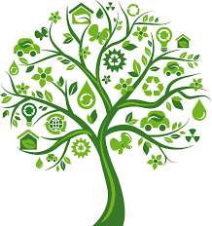

**Music**

* Play an untuned instrument – Recorder

**Geography**

* Creating maps of an area with scaled drawings.
* Using symbols and creating corresponding keys.
* Use field work to identify physical and human features.
* Locate counties and cities on a map.

**RE**

* Explore philosophical questions.
* Issues of fairness and justice right and wrong.

**Art**

* Sketching of wild flowers and nature with annotations (links with geography).
* Experiment with watercolours and colour mixing

**PE**

* Athletics
* Striking and fielding.

**Mathematics**

* Measurement – Time
* Geometry – Properties of shape.
* Measurement – Mass and Capacity.
* Consolidation and gap filling of number.

**English**

* Persuasive writing.
* Poetry
* Letter writing regarding an ecological issue.
* Non chronological report.
* Drafting, editing, proof reading and presenting their work.
* Possessive apostrophes.
* extending the range of sentences with more than one clause by using a wider range of conjunctions, including: when, if, because, although

**PSHCE**

* Mindfulness
* School values
* Growth mindset

**ICT**

•  Branching key for identifying.

* Creating a data base.

**Science**

**Plants**

* Labelling the parts of a plant.
* Investigation – What plants need to grow well.
* Investigation – results what have we found out?
* How water moves though a plant.
* The part flowers play in the life cycle of a flowering plant.
* The life cycle of a flowering plant.

**DT**

* Plan, design and create a working model using a range of self selected tools.
* Investigate the seasonality of different foods.
* Investigate local foods and produces.

**French**

* How old are you?
* I am….years old
* Where do you live?
* I live in…
* Landmarks in the UK and capital cities
* Definite article “the” – le, la l’
* Introducing yourself and describing where you come from

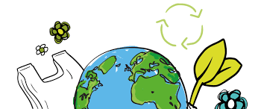

**Sustainability**

Australasia Class

**RSE**

* Transition
* Emotional resilience
* Sense of self