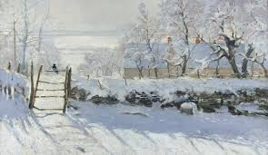

**RE**

* Understanding the differences in the way that Christmas is celebrated around the world.
* Look at important festivals and celebrations – Advent compared to Diwali.

**Geography**

* Identifying places around the world (through the study of stitches in Art)
* Use maps, atlases and globes to locate countries.

**Music**

* Play an un-tuned instrument – djembe drums.

**PSHCE**

* Dealing with strong emotions
* Self-image, mental health and well-being

**DT**

* Choosing and using materials and tools to make own printing tile e.g. card template with a string raised relief.
* Explaining own choice of materials and tools.

**RSE**

* Online relationships and the media
* Online content and critical thinking
* Staying safe online

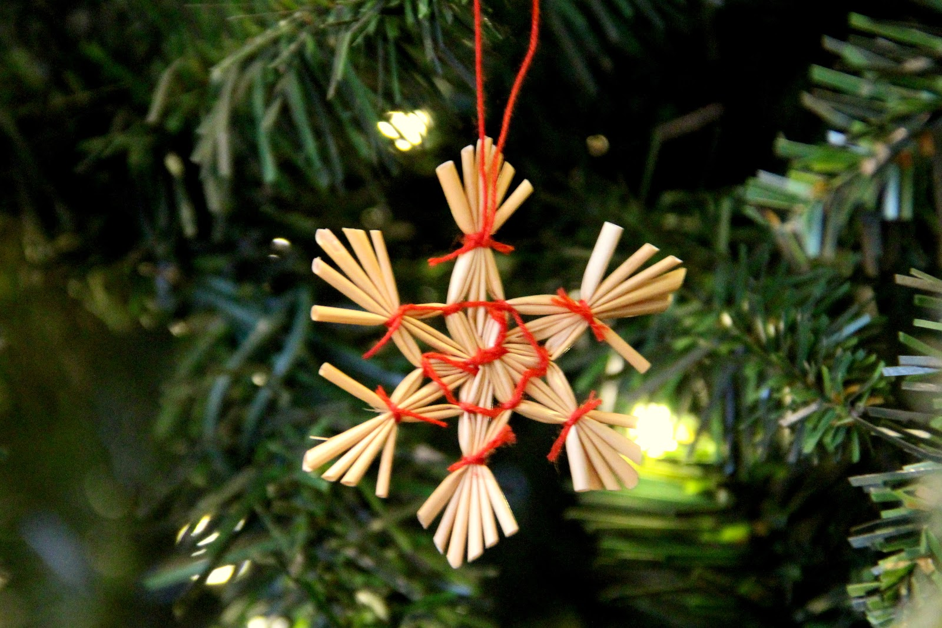

**Yule**

Australasia Class

**PE**

Netball

* Use running, jumping, throwing and catching in isolation and in combination;
* Play competitive games, modified where appropriate.
* Apply basic principles suitable for attacking and defending.

**Science**

**Light**

* Know that we need light to see
* Understand reflective surfaces
* Understanding shadows
* Know that the light from the sun can be dangerous

**French**

* Greetings
* What’s your name?
* France and Paris
* Classroom phrases
* Pronunciation
* Paris’ landmarks
* UK and capital cities
* Counting 1-6
* Simple sentences using it is/this is/ yes/no

**English**

Understanding the 4 types of sentences.

Creating direct speech and using commas.

Organising writing into paragraphs.

Understanding and creating expanded noun phrases for descriptive writing.

Writing a Stone Age adventure story.

Creating winter themed poetry.

**Mathematics**

* Addition
* subtraction
* Multiplication
* Division

**Art**

* Painting winter themed pictures using ideas from famous artists.
* Experiment with watercolours and colour mixing – exploring colour intensity.
* Creating own Christmas wrapping paper using printing techniques – low relief string on card printing
* Use more than 1 colour when printing.
* Experiment with repeated patterns and overlays when printing
* Research embroidery designs from around the world.
* Create own embroidery designs.
* Sew simple stitches in embroidery.
* Create a fabric collage