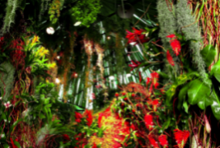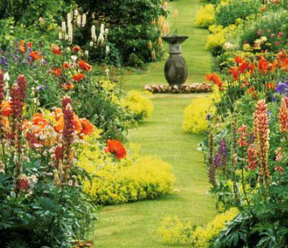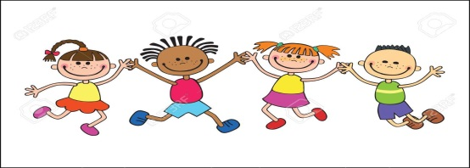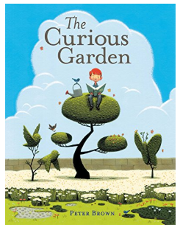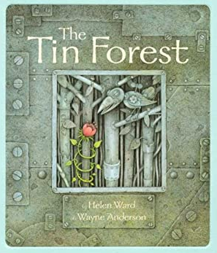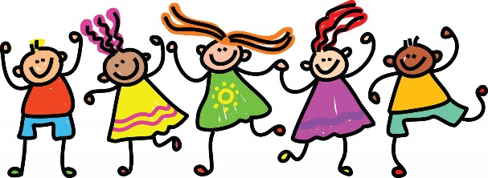

**Art, DT & Music**

**ART & DT**

We will be linking our art and DT closely this half term; learning to create and experiment with shades of colour and recognising warm and cold colours through creating a colour wash back drop to compliment the class ‘Tin Forest’ that we will build together. This will allow us to explore how simple structures can be made stronger. Stiffer and more stable by overlapping materials such as foil and cardboard.

**Music -** Following the West Sussex Music Programme: Improvising and composing

• creating music for story and soundscapes

• creating rhythms using flashcards for choices

• melodic tunes using known notes

**Foundation Subjects**

**Geography – place knowledge**

We will be exploring geographical similarities and differences by exploring a small area of the UK with a small area of a non-European country. We will look at how the climate in the UK suits some plants but not all and compare this to the plants that grow in the Amazon Rainforest.

**RE**

This half term we will consider the celebration of Easter, what it means to Christians and how and why we celebrate it.

**Science**

**Science – Plants**

We will be observing and describing how seeds and bulbs grow into plants by planting our own seeds (sunflowers, sweet peas and nigella plants). We will find out how plants need water, light and a suitable temperature to grow by carrying out an experiment where we place plants in different conditions to see the effect it has on them. This will link to our learning in Geography, where we will be comparing the rainforest climate to the UK.

**French** – For the Spring Term, we will be focussing on

- Animals, parts of the body, family and counting from 6-10

**Computing**

This half term we will be exploring algorithms and creating and using a set of simple instructions. We will talk about errors and think carefully about the behaviour of simple programs.

**Mathematics**

**Fractions**

- recognise, find, name and write fractions 1/3, ¼, 2/4, ¾ of a length, shape, set of objects or quantity

- write simple fractions for example, 1/2 of 6 = 3 and recognise the equivalence of 2/4 and ½ .

**Statistics**

-interpret and construct simple pictograms, tally charts, block diagrams and simple tables

-ask and answer simple questions by counting the number of objects in each category and sorting the categories by quantity

- ask and answer questions about totalling and comparing categorical data.

**English**

**Speaking and Listening**

This half term we will continue to build upon our ability to listen and respond appropriately to adults and their peers by thinking carefully before we speak and questioning if our questions are relevant to extend our understanding and knowledge. Talking is a huge part of how we learn and by taking part in discussions we are able to develop our vocabulary, understanding, imaginations and viewpoints.

**Reading** This half term we will be continue to explore learning opportunities via our key texts, getting to know them really well and understanding the any new vocabulary we are presented with. We will be building our fluency and ability to add expression within our guided reading groups and during the times we get to read to ourselves in class. By continuing to embrace reading, we will develop confidence and fluency in our word building, identify and develop our own opinions as a reader and develop our understanding why certain books are structured in different ways.

**Writing (half term focus; story writing, poetry, non-fiction writing and editing skills)**

This half term we will continue to develop a positive attitude towards writing and build our stamina to write for longer periods. We will explore writing for different purposes via diary entries, character description and predicting what will happen based on what we have read etc. We will plan our writing before we write it, either verbally or by writing ideas down using new vocabulary we have learnt. We will edit our writing by re-reading to check it makes sense to us and the reader and make simple additions and changes to improve it.

**There was once a wide, windswept place, near nowhere and close to forgotten…**

**RSHE**

**Core School Value: BELIEVE – positivity & care**

This term we will be exploring what it means to be have belief in ourselves and others. We will learn what it means to be positive and that this quality is important to help us be the best we can be. We will work together to show care towards our peers.

**Growth Mindset**

We will continue to develop our growth mindset by believing in ourselves and learning from experience. We will continue to embrace the power of yet and give everything a try. We will develop our understanding of resilience and work together in collaboration towards a shared goal.

**KEY TEXTS**

* **The Tin Forest By Helen Ward**
* **The Curious Garden by Peter Brown**
* **Information books about plants and growing**

**Europe Class – Spring 2**

**PE-**

**Dance and Gymnastics**

This term we will be learning how to perform a sequence of movements in a routine, as well as using equipment in different ways.

**Ready Steady Sow!**

**EUROPE**