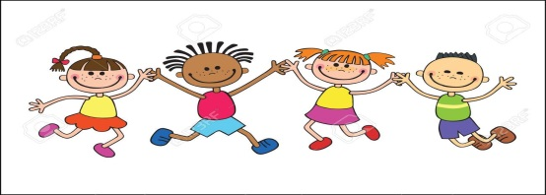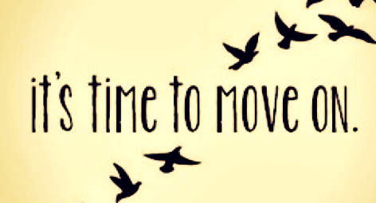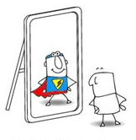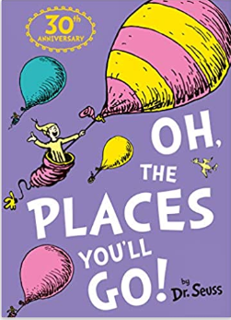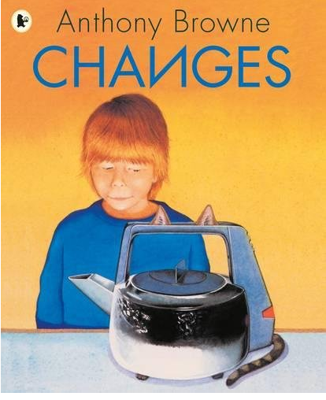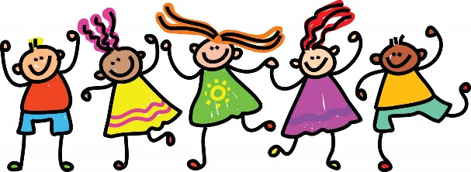

**Art, Dt & Music**

**DT**

In our DT learning this half term, we will be linking our learning with history to discuss how products have changed over the years and why; whilst designing a product for the future and considering changes along the way to make it better.

**ART**

We will be developing our skills in observational drawing, using line and detail to draw a detailed portrait of ourselves. This will help us think about how we will continue to change in the future.

**Music -** Following the West Sussex Music Programme: Performing

* Awareness of audience

We will compose and theme tune for ourselves – what would we sound like if we were a melody?

**French** – For the summer term we will be learning to say the names of fruits, talk about the weather (hot/cold) and the clothes we might wear, as well as counting 11-12

**Mathematics**

**Number – Problem Solving**

-solve problems with addition and subtraction: using concrete objects and pictorial representations, including those involving numbers, quantities and measures

-applying their increasing knowledge of mental and written methods

-solve problems involving multiplication and division, using materials, arrays, repeated addition, mental methods, and multiplication and division facts, including problems in contexts.

**Measurement – mass and capacity, time**

- compare and sequence intervals of time

- tell and write the time to five minutes, including quarter past/to the hour and draw the hands on a clock face to show these times

- know the number of minutes in an hour and the number of hours in a day.

- choose and use appropriate standard units to estimate and measure mass (kg/g); temperature (°C); capacity (litres/ml) to the nearest appropriate unit, using scales, thermometers and measuring vessels

- compare and order mass, volume/capacity and record the results using >, < and =

**Geometry – position and direction**

- order and arrange combinations of mathematical objects in patterns and sequences

- Use mathematical vocabulary to describe position, direction and movement, including movement in a straight line and distinguishing between rotation as a turn and in terms of right angles for quarter, half and three-quarter turns (clockwise and anticlockwise) – linked within PE sessions

**PE - Athletics/Tennis**

This term we will be developing our skills in tennis, athletics and striking and fielding. This carefully about the positions we need to put our bodies in to achieve maximum impact and effect.

**English**

**Speaking and Listening**

This half term we will using our ability to listen and respond appropriately to adults and their peers, to help us reflect on our time in Year 2. We will be by thinking carefully before we speak and sharing our thoughts and opinions with others. We will be questioning if our questions are relevant to extend our understanding and knowledge. Talking is a huge part of how we learn and by taking part in discussions we are able to develop our vocabulary, understanding, imaginations and viewpoints. We will celebrate our successes and consider what we still need to work on.

**Reading** This half term we will be continue to explore learning opportunities via our key texts, getting to know them really well and understanding the any new vocabulary we are presented with. We will be building our fluency and ability to add expression within our guided reading groups and during the times we get to read to ourselves in class. By continuing to embrace reading, we will develop confidence and fluency in our word building, identify and develop our own opinions as a reader and develop our understanding why certain books are structured in different ways.

**Writing (half term focus; story writing, poetry, non-fiction writing and editing skills)**

This half term we will continue to develop a positive attitude towards writing and build our stamina to write for longer periods. We will explore writing for different purposes via real life events, when we write about our lives, letter writing when we write a letter to our seven year old self. We will plan our writing before we write it, either verbally or by writing ideas down using new vocabulary we have learnt. We will edit our writing by re-reading to check it makes sense to us and the reader and make simple additions and changes to improve it.

**Foundation Subjects**

**RE**

This half term we will consider the Christian ritual of a Baptism. What is it for and why?

**Geography – field work**

We will be using observational skills to look at the school and its grounds; perhaps interviewing the head teacher as to how the school has changed and why.

**History – Continuity and Change**

We will be thinking about and discussing how we have changed over time and other changes within our living memory. We will look at our immediate family and develop our vocabulary of historical terms such as recently, a long time ago, younger etc.

**Wherever you fly, you’ll be best of the best. Wherever you go you will top all the rest!**

**Computing – we will be using technology purposefully; using a basic word package to type up a letter to our future self.**

**KEY TEXTS**

* **Changes By Anthony Browne**
* **Oh. The places you’ll go by Dr. Seuss**

**RSHE**

**Core School Value: ACHIEVE – Celebration & happiness**

This term we will be exploring what it means to achieve and be successful. We will reflect on all we have achieved and celebrate all our efforts. We will continue to develop how we can make ourselves and others happy.

**Growth Mindset**

We will continue to develop our growth mindset by celebrating our achievements. We will continue to embrace the power of yet and give everything a try. We will develop our understanding of perseverance and respect via talking and circle times.

**Europe Class – Summer 2**

**Everything Changes!**

**EUROPE**