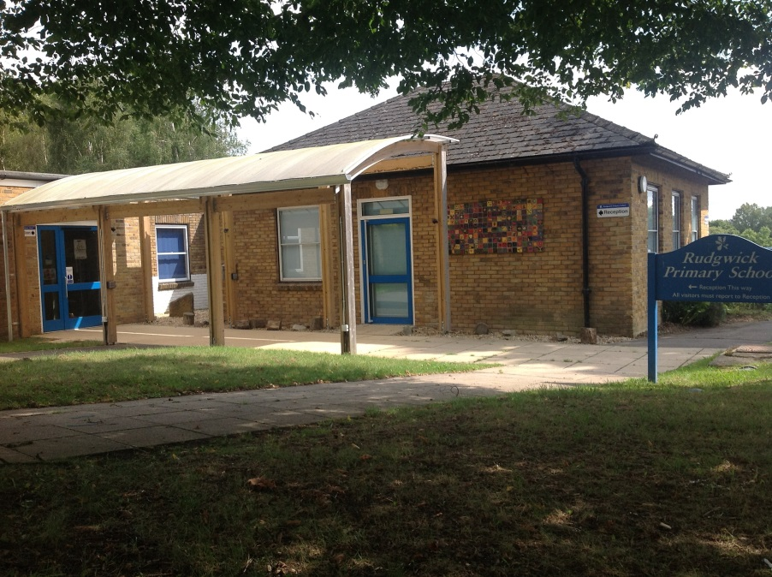

To apply for a place at Rudgwick Primary School:-
Children starting school in September 2021: The West Sussex County Council website contains details of the on-line application process, which opens on Monday 5th October 2020 and closes on Friday 15th January 2021. For residents outside West Sussex you will need to apply through the relevant local authority for your home address.
Children who currently attend school elsewhere: You will need to contact the admissions office or complete the on-line In Year Application form at https://www.westsussex.gov.uk/education-children-and-families/schools-and-colleges/school-places/apply/moving-school/
West Sussex Admissions can be contacted on 03330 142 903 or admissions.north@westsussex.gov.uk
More information regarding admissions can be found at www.westsussex.gov.uk/admissions

