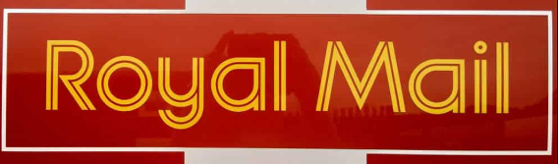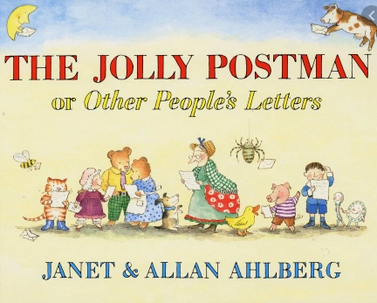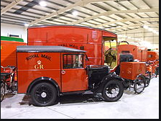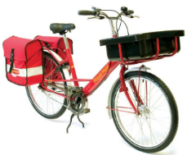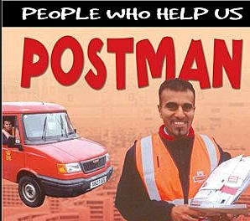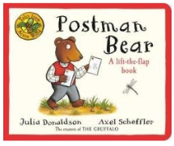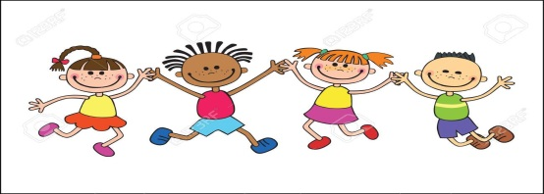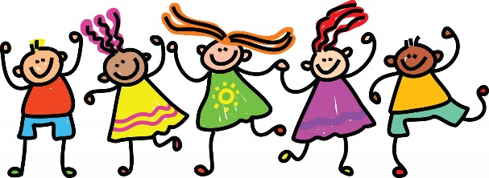

**Art, DT & Music**

**ART**

We will be considering sculpture this half term. We will investigate a range of materials and experiment how they can be connected together to form simple structures. We will look at sculptures and begin to form our own 3D pieces by making a new bicycle for the Jolly Postman. This will link to our science learning on everyday materials.

**Music -** Following the West Sussex Music Programme: Instrument Technique

* good sound quality and dynamics
* general percussion – grouping and playing confidently
* djembes – bass, tone and singing notes
* recorders – holding correctly, tonguing, (C) B A G
* ukuleles – holding correctly, “thumb brush strum”, C chord, Am chord

**French** – For the Spring Term, we will be focussing on

- Animals, parts of the body, family and counting from 6-10

**Foundation Subjects**

**Geography – map skills**

We will be identifying and uses simple picture maps from our key text, following routes and using simple compass directions. We will make a map of a journey we take and try to find our house on Google Earth.

**History**

We will be using our key texts to explore historical enquiry – asking questions about the postal service and learning when it all began and why. We will be learning about ways in which we can find out about the past from pictures, stories and websites etc.

**RE**

This half term our focus is Judaism. We will be learning to recall and name beliefs, ways of life and festivals in the Judaism calendar and find out the meanings behind them. We will explore where Jews worship and what the Torah is, as well as exploring what Jews believe about the Messiah.

**Science**

**Science – Everyday Materials**

We will be identifying and comparing the suitability of everyday materials and how they can be used for particular purposes. We will explore how shapes of some solid materials can be changed by stretching, squashing and bending etc. We will investigate this area of science by making a new bicycle for the Jolly Postman – linked to Art.

**Mathematics**

**Number – multiplication and division**

* Recognise, make and add equal groups
* Multiply using the x symbol
* Solve multiplication sentences using pictures
* Explore arrays
* Make doubles
* Begin to learn the 2x tables, 5x tables and 10x tables
* Make equal groups – through sharing and grouping
* Begin to divide by 2, 5 and 10
* To review odd and even numbers

**Geometry – properties of shape**

* Recognise 2D and 3D shapes
* Count sides and vertices of 2D shapes
* Draw 2D shapes
* To recognise and draw lines of symmetry
* Sort 2D &3D shapes and make patterns with them
* Count faces, edges and vertices on 3D shapes

**PE –**

**Dance and Gymnastics**

This term we will be learning how to perform a sequence of movements in a routine, as well as using equipment in different ways.

**English**

**Speaking and Listening**

This half term we will continue to build upon our ability to listen and respond appropriately to adults and their peers by thinking carefully before we speak and questioning if our questions are relevant to extend our understanding and knowledge. Talking is a huge part of how we learn and by taking part in discussions we are able to develop our vocabulary, understanding, imaginations and viewpoints.

**Reading** This half term we will be continue to explore learning opportunities via our key texts, getting to know them really well and understanding the any new vocabulary we are presented with. We will be building our fluency and ability to add expression within our guided reading groups and during the times we get to read to ourselves in class. By continuing to embrace reading, we will develop confidence and fluency in our word building, identify and develop our own opinions as a reader and develop our understanding why certain books are structured in different ways.

**Writing (half term focus; story writing, poetry, non-fiction writing and editing skills)**

This half term we will continue to develop a positive attitude towards writing and build our stamina to write for longer periods. We will explore writing for different purposes via story writing, letters and factual based writing. We will plan our writing before we write it, either verbally or by writing ideas down using new vocabulary we have learnt. We will edit our writing by re-reading to check it makes sense to us and the reader and make simple additions and changes to improve it.

**RSHE**

**Core School Value: BELIEVE – resilience & collaboration**

This term we will be exploring what it means to be have belief in ourselves and others. We will learn what it means to be resilient and that this quality is important to help us be the best we can be. We will work together on collaborative projects such as designing and building simple structures.

**Growth Mindset**

We will continue to develop our growth mindset by believing in ourselves and learning from experience. We will continue to embrace the power of yet and give everything a try. We will develop our understanding of resilience and work together in collaboration towards a shared goal.

**Once upon a bicycle,**

**Or so they say,**

**A Jolly Postman came one day,**

**From over the hills and far away…**

**KEY TEXTS**

* **The Jolly Postman By Janet & Allan Ahlberg**
* **Postman Bear By Julia Donaldson**
* **Information books about people who help us in the community**

**Europe Class – Spring 1**

**Once Upon A Bicycle**

**EUROPE**