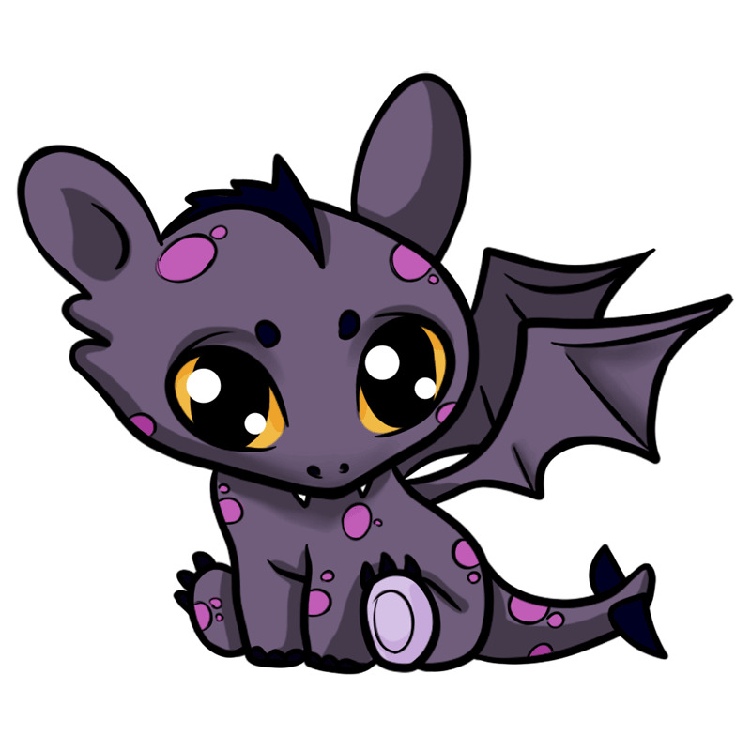

**Mathematics**

* Multiplication – 2-digit x 1-digit
* Division – 2-digits by 1-digit
* Dividing 100 into equal parts
* Dividing with remainders
* Scaling
* Counting money
* Converting money
* Adding money
* Subtracting money and giving change
* Tally charts
* Bar charts
* Pictograms
* Tables

**PE**

Gymnastics

* Develop flexibility, strength, technique, control and balance [for example, through athletics and gymnastics].
* Compare their performances with previous ones and demonstrate improvement to achieve their personal best.

**History & Geography**

* Look at where dragons have historically been reported in the UK – locate the UK on a variety of different maps, names and locate the countries and the cities of the UK.

**RE**

* Identify and rights of passage – baptism, marriage
* Compare with Hindu samskaras.

**French**

* Conjunction or/ and
* Spelling
* Landmarks in Paris
* Number labels
* Counting to 12
* New verb – there is
* Adverbial phrases “in Paris” and “also”
* What’s your name?
* My names is….

**English**

* Instruction writing – how to make a dragon catching device
* Diary writing – the day I grew a dragon
* Labelling a drawing – dragon producing plant
* Story writing – dragon adventure
* Publishing finished dragon stories to produce little books to share.

**DT**

* Balanced and healthy diet
* Know that to be active and healthy, food is needed to provide energy for the body

**Art**

* Use sketchbooks to record **drawings of fangs and claws from observations** e.g. photographs and pictures online and in books
* Experiment with different tones using graded sketching pencils
* Develop shadows
* Experiment with watercolour to **paint dragons**
* Use a variety of brushes and experiment with ways of mark making
* Mix and match colours to create own colour palette
* Lighten and darken tones

**Fangs & Claws**

Australasia Class

**RSE**

* Drugs, Alcohol and Tabaco
* Eating well and being active.

**PSHCE**

* Online relationships
* Mental health and mindfulness

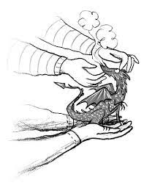

**Science**

**Animals including humans**

* Identify the amount and types of nutrition that animals and humans need
* Know that animals cannot make their own food and get nutrition from what they eat

**Music**

* Play a tuned instrument – ukulele